# Exercises: Cryptocurrency Wallets and Transactions

This document describes the **exercise assignments** for the ["Blockchain Academy" course @ Software University](https://softuni.bg/courses/programming-fundamentals). In this lesson we learned the basic types of **Cryptocurrency** **wallets** and how to make **transactions** with them. During the exercise you will **install** and **run** several different **wallets** and then make some transactions on a **testnet** in order to get familiar with the process.

## Install and Run Jaxx Wallet

1. Open [https://jaxx.io](https://jaxx.io/)
2. 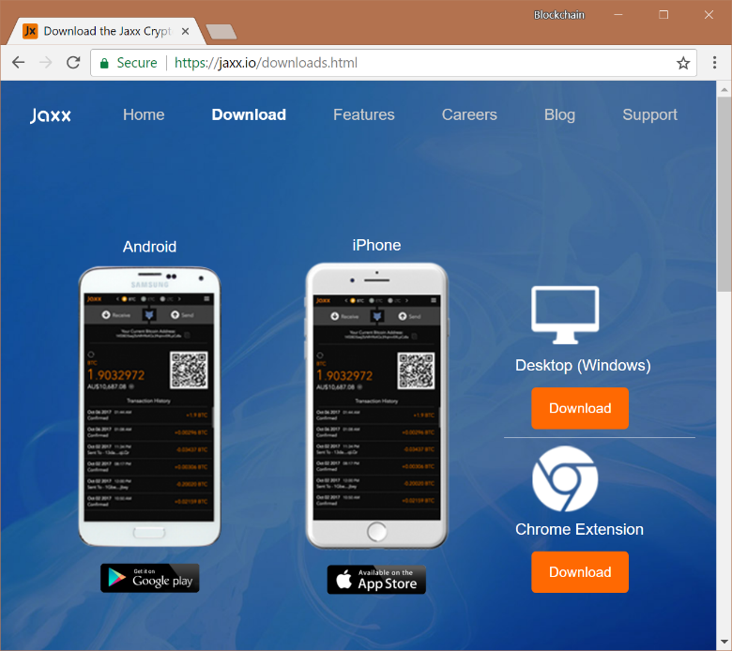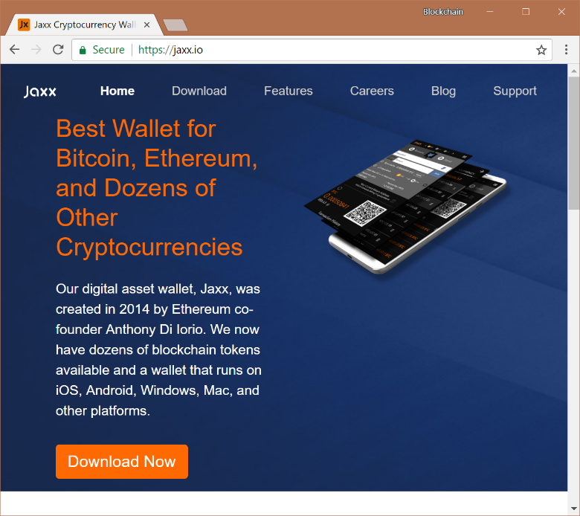Click **“Download Now”** and then select **“Chrome Extension”**:
3. 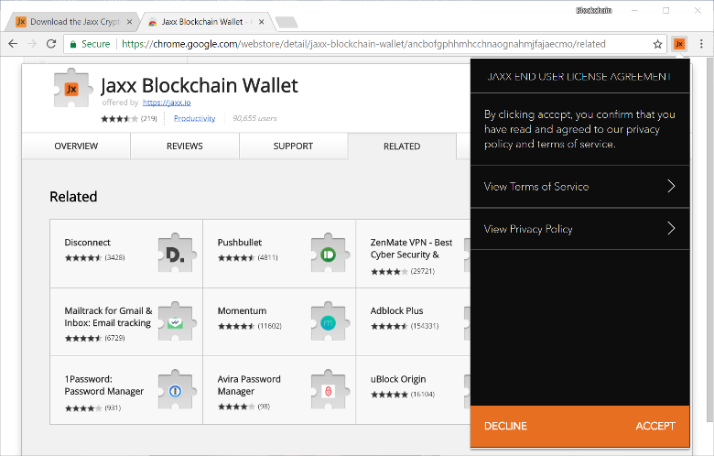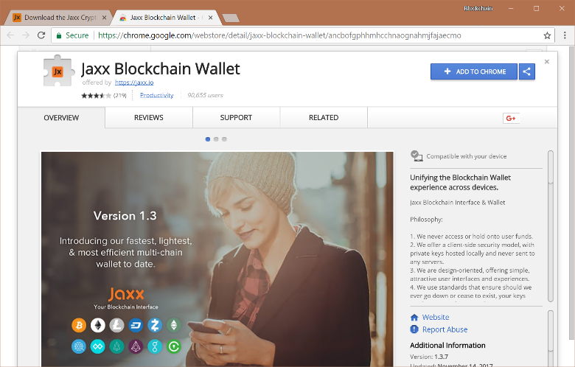Download the Chrome extension and accept the **End User License Agreement**:

## Configure the Wallet, Send and Receive coins

1. Click on **“Create new Wallet”**
2. 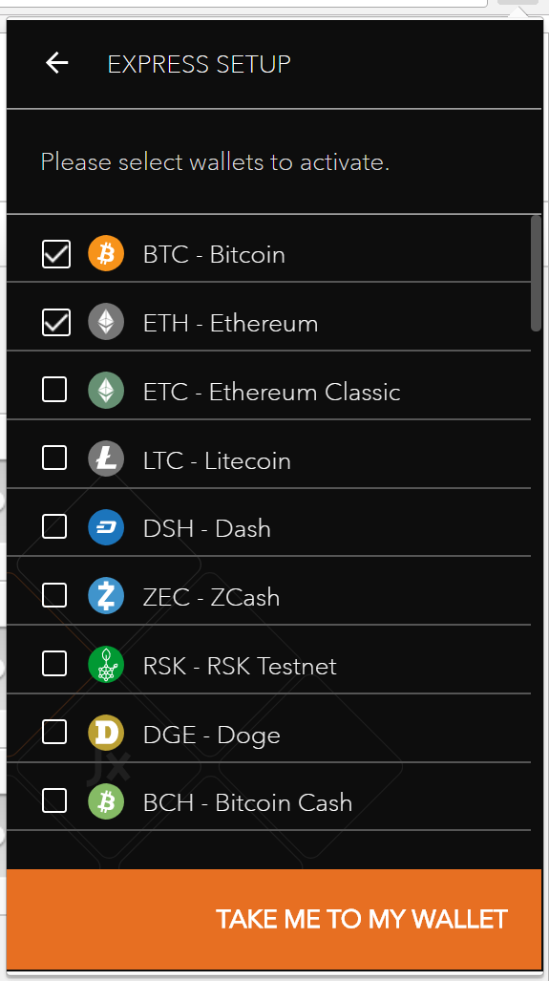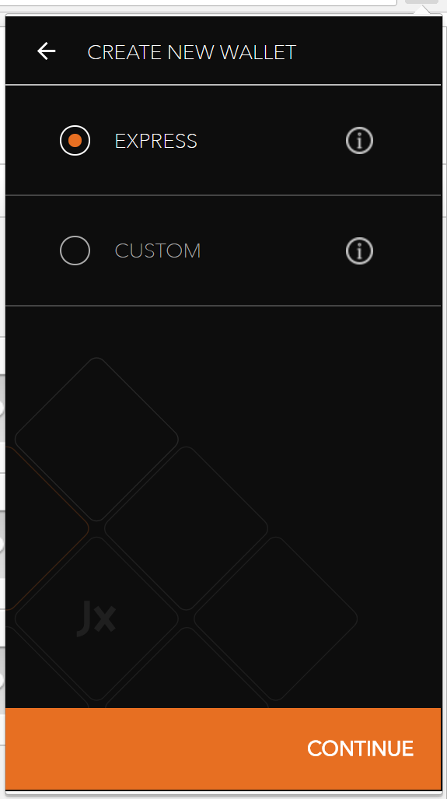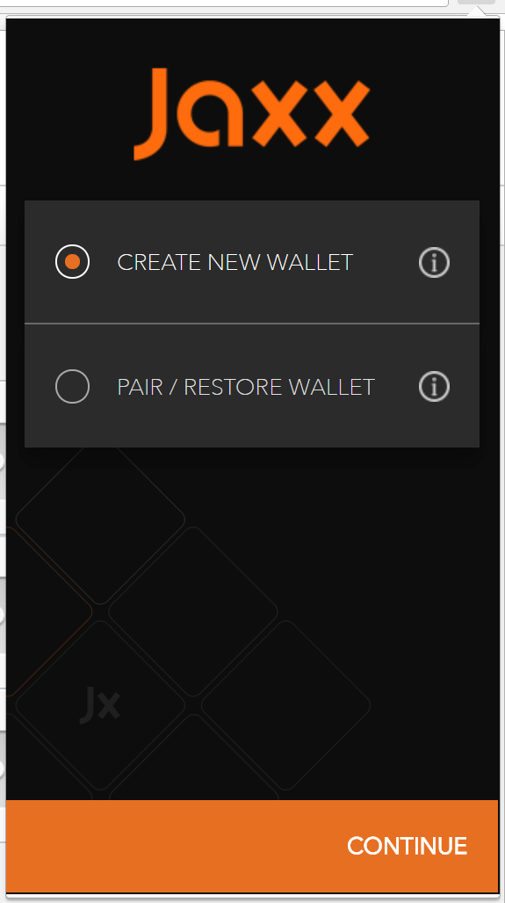Set Express installation and choose Bitcoin (BTC) and Ethereum (ETH):
3. Select **“Menu”** -> **“Wallets”**.
4. 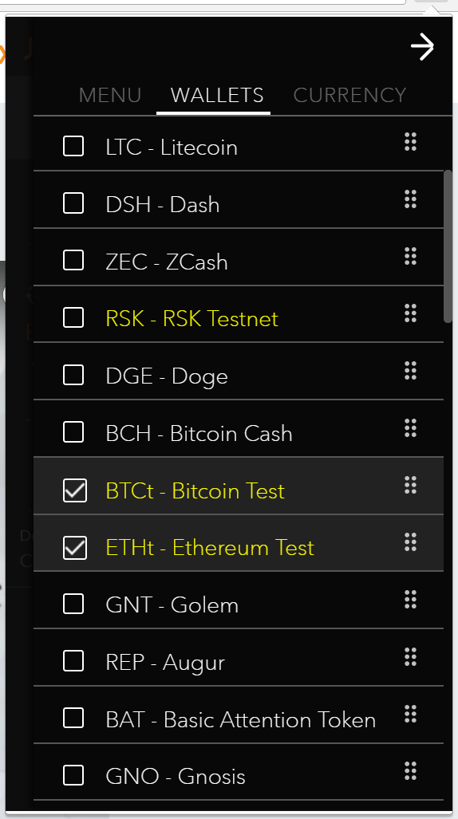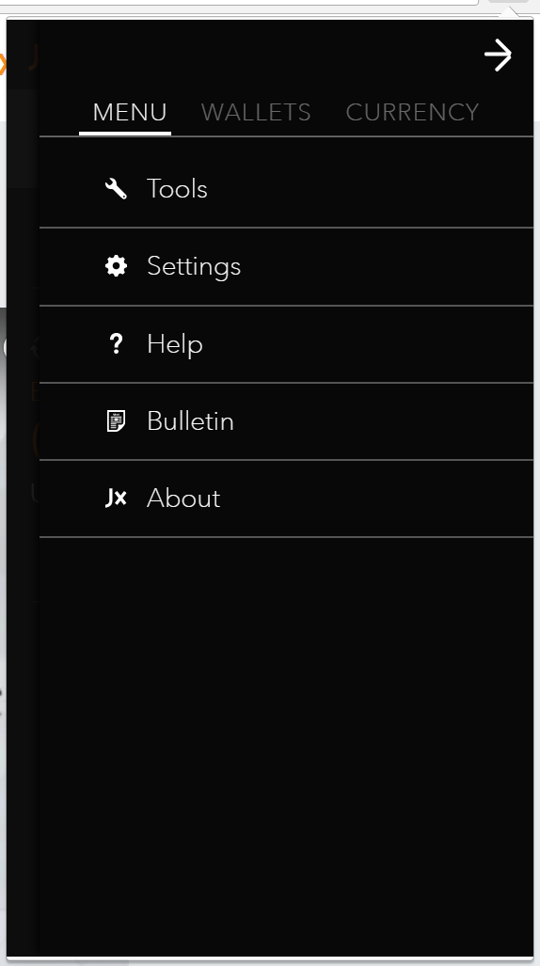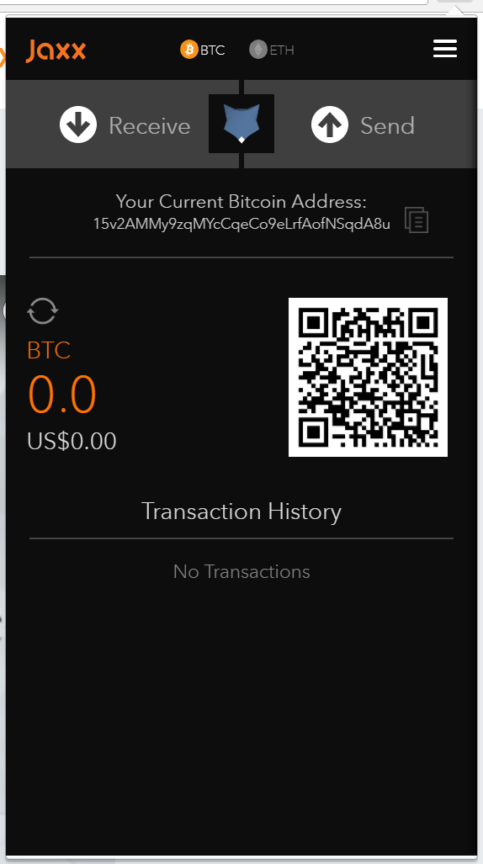Add Bitcoin Test and Ethereum Test wallets (**BTCt**, **ETHt**):
5. 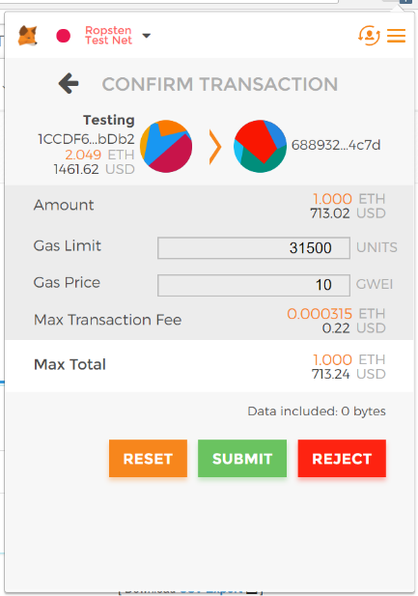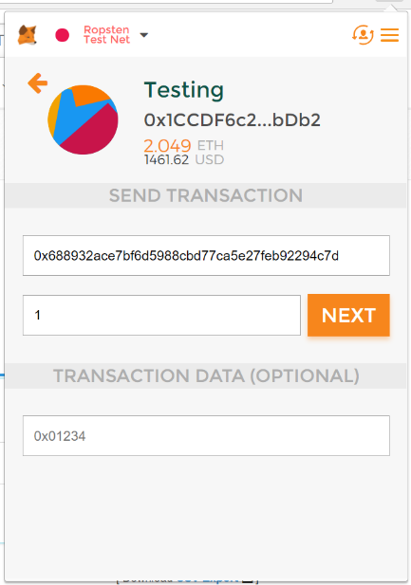Now you are ready to receive some test coins. Go to **Metamask** and send some testnet coins to your new **Jaxx** wallet:

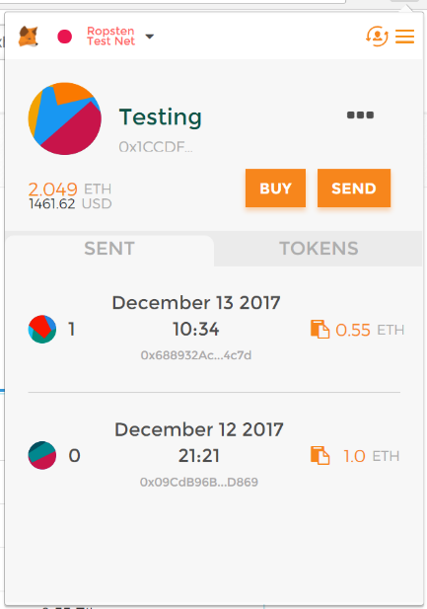

1. Now check your **Jaxx** **ETHt** wallet and see some Ethereum. You can now start trading with the others around you:

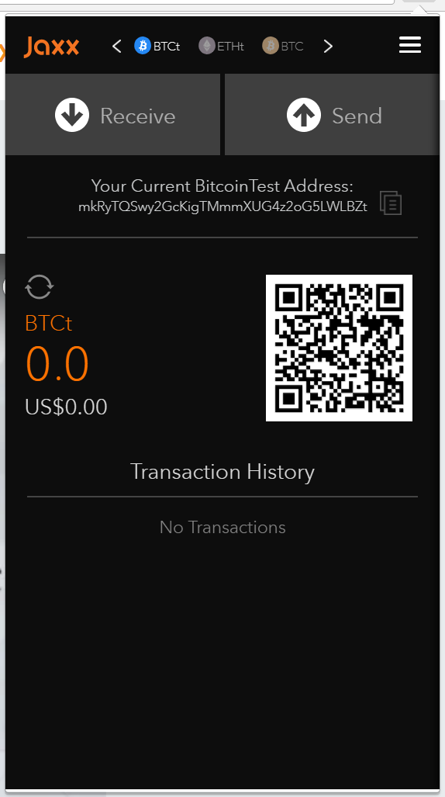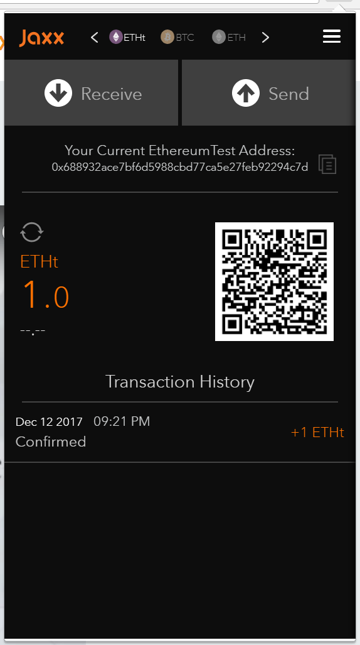

**Note:** **ETHt** addresses in **Jaxx** change every time you receive some coins on them. **Jaxx** is **masking** your current address, so no one from the testnet can see where the funds are going to. Anyway, when you are sending coins through the testnet it will appear as though you send them through your **ETH** wallet. We will see this in the next exercise. Now just send some coins to other wallets.

1. 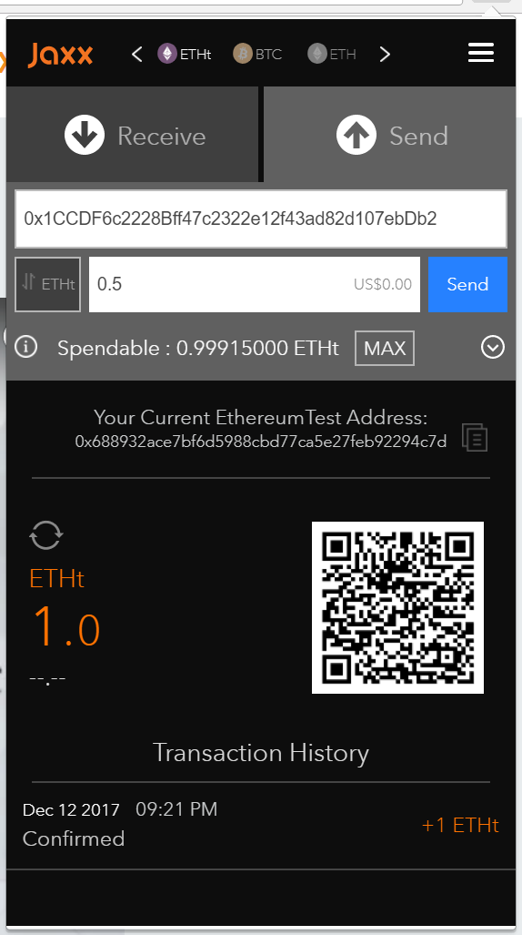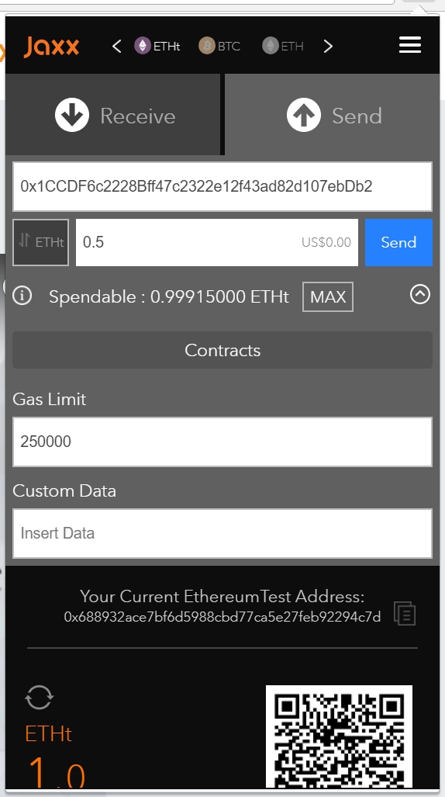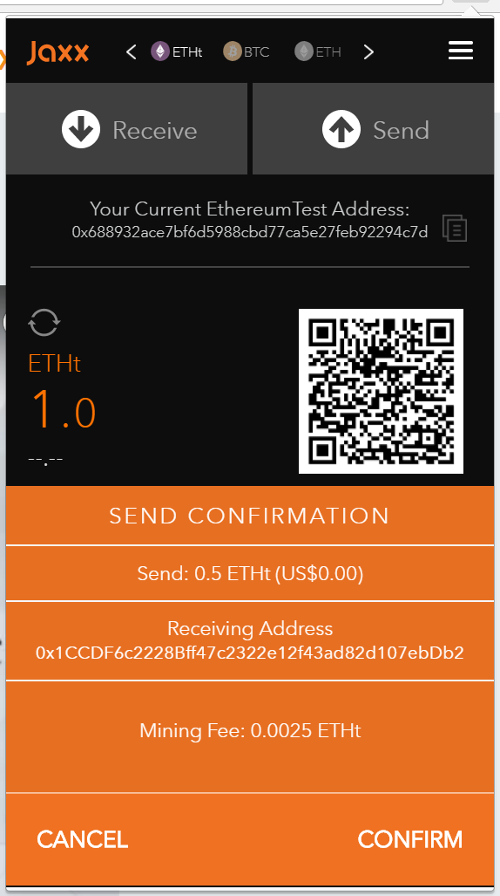Send some **Ethereum** to someone around you. Set the amount and check the details of your transaction:
2. You can see your transaction history at the bottom of the screen:

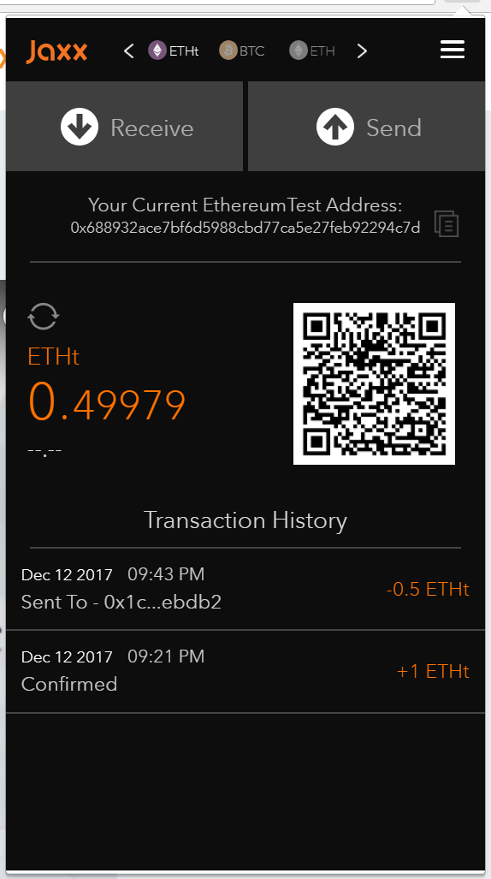

## Check your Transactions at Etherscan

1. Open [https://etherscan.io](https://etherscan.io/)
2. Copy our current **EthereumTest** Address from **Jaxx** and paste it in the search field:

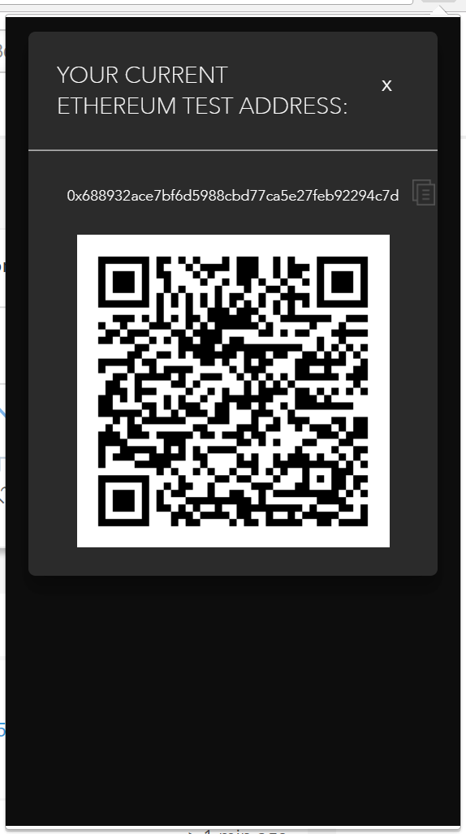

1. 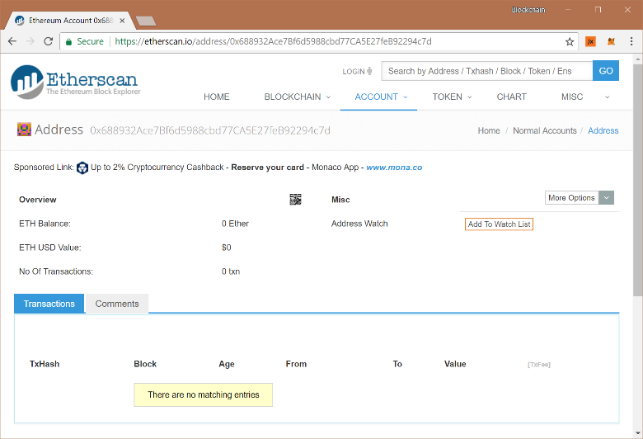Note that nothing is showing. This is because we are not working on the **real network**, but on a **testnet**.
2. 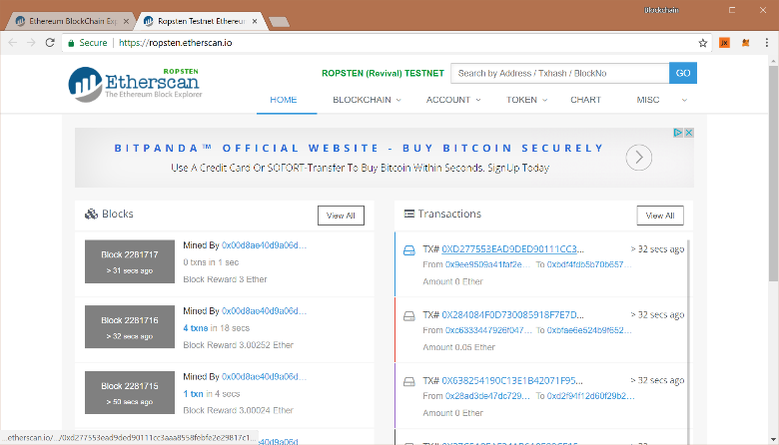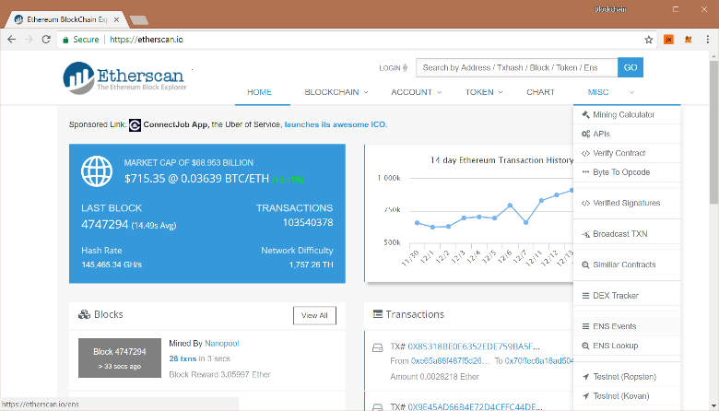Go to **MISC** and then select **Testnet** (**Ropsten**):
3. Now paste your address again to see the information for your transactions:

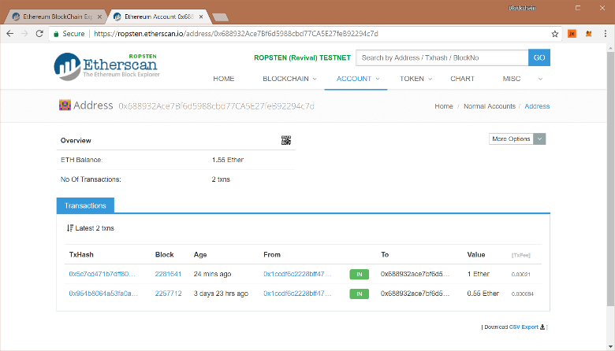

1. 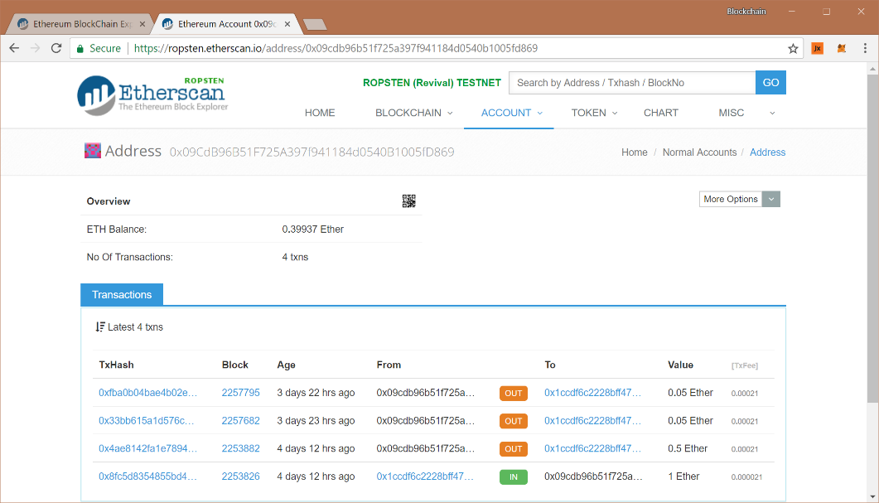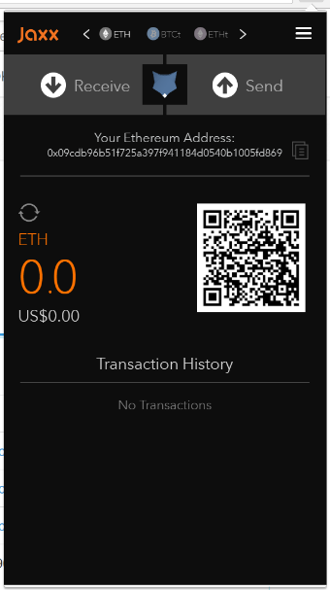Now take your real **ETH** wallet address from **Jaxx** and check with it:

Here you can see all your OUT transactions in the **testnet**, even though you are looking with your real **ETH** address. This is because **Jaxx** is using your real **ETH** address for all transactions, but gives you masked other addresses for incoming transactions, so it is harder for someone to track you on the testnet.

# What to Submit?

Submit as exercise outcome the **URL of your Ethereum address** in the Ropsten network at EtherScan, e.g.:

* <https://ropsten.etherscan.io/address/0x09cdb96b51f725a397f941184d0540b1005fd869>

You should see some **ETH** in your balance, as well as some transaction history of ETH transfers.